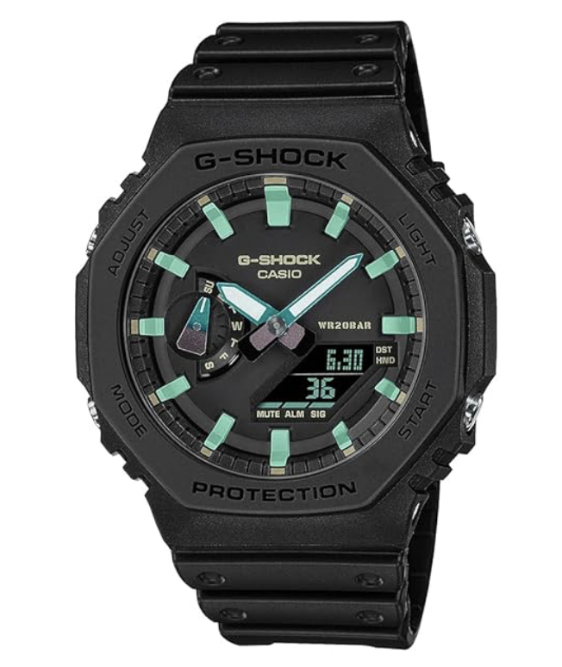

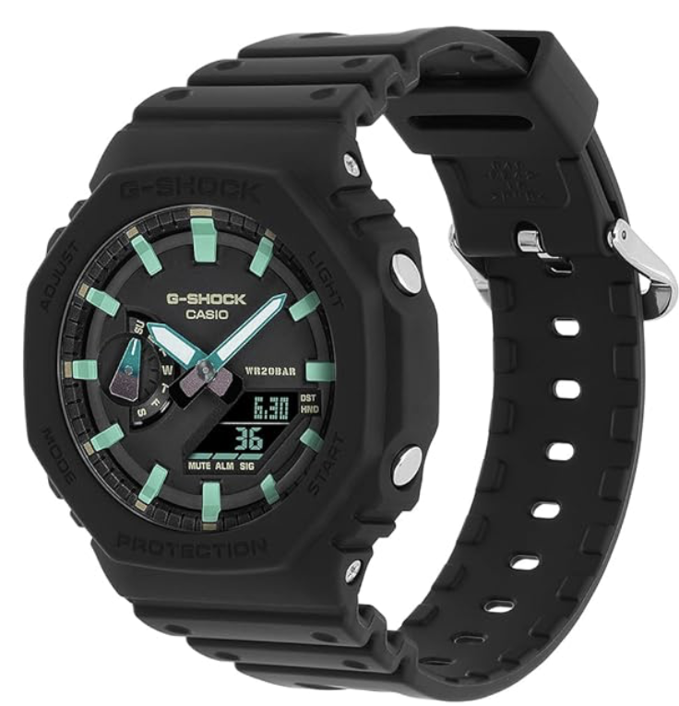

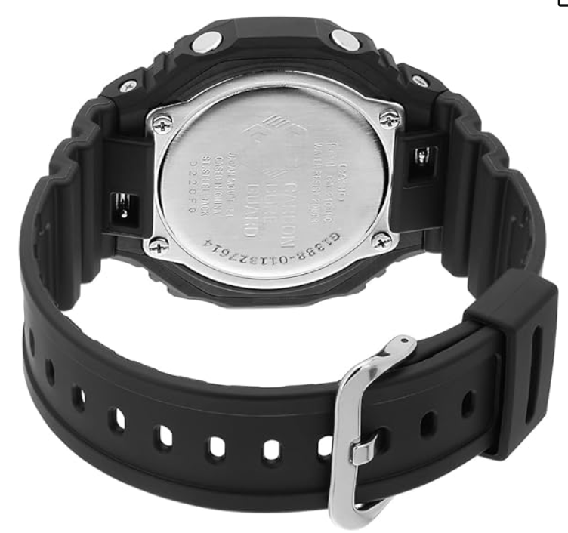

Casio G-Shock Men Black Dial Analog-Digital

Black and blue, stainless steel, water resistant

analog, digital, black, blue, water resistant, stainless steel, men

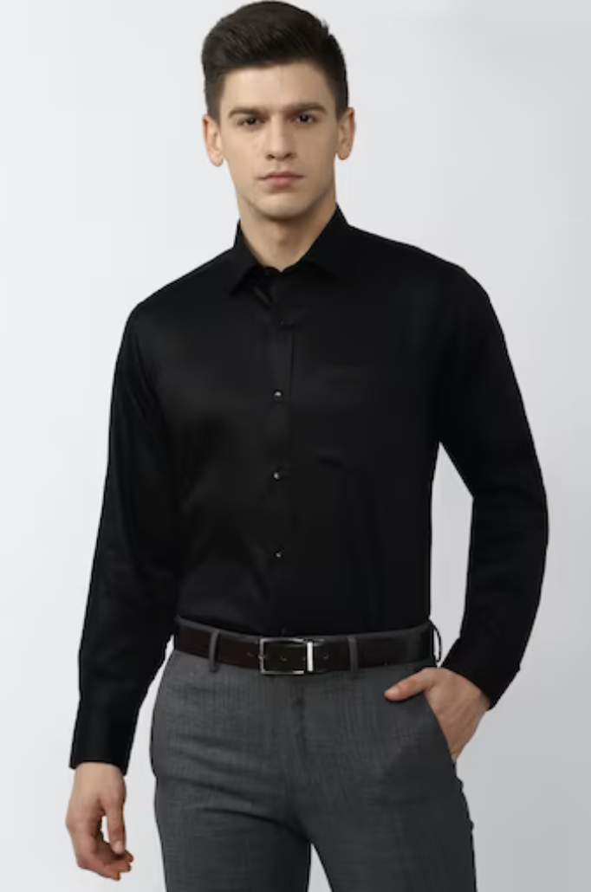

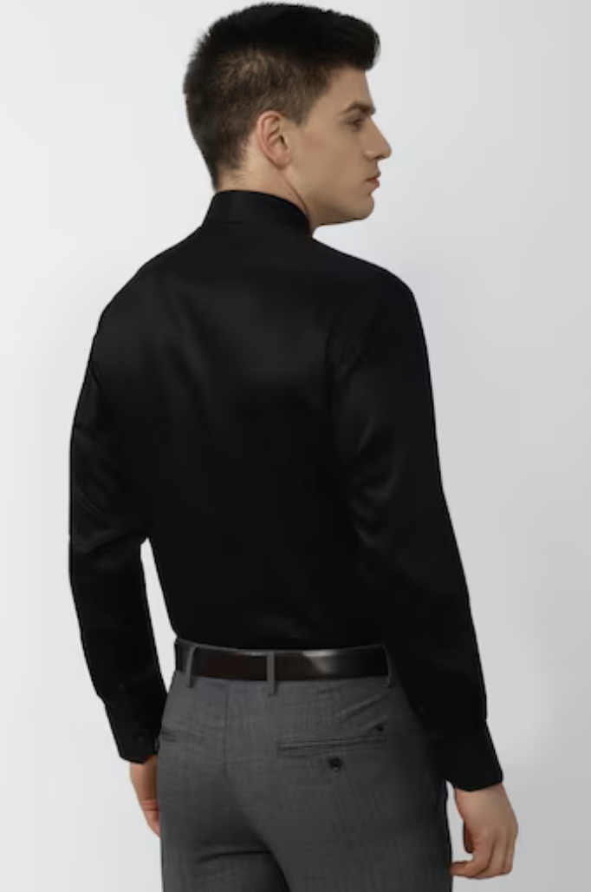

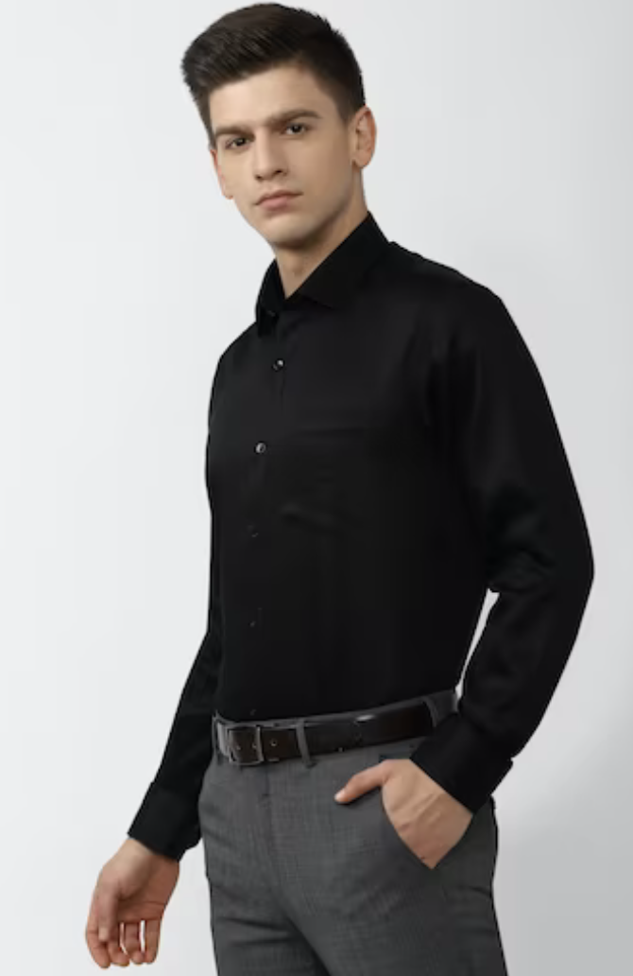

Men Black regular Fit Full sleeves Formal Shirt

Black Solid shirt, tailored in Regular Fit from Van Heusen

Black, shirt, men, regular fit, Van Heusen

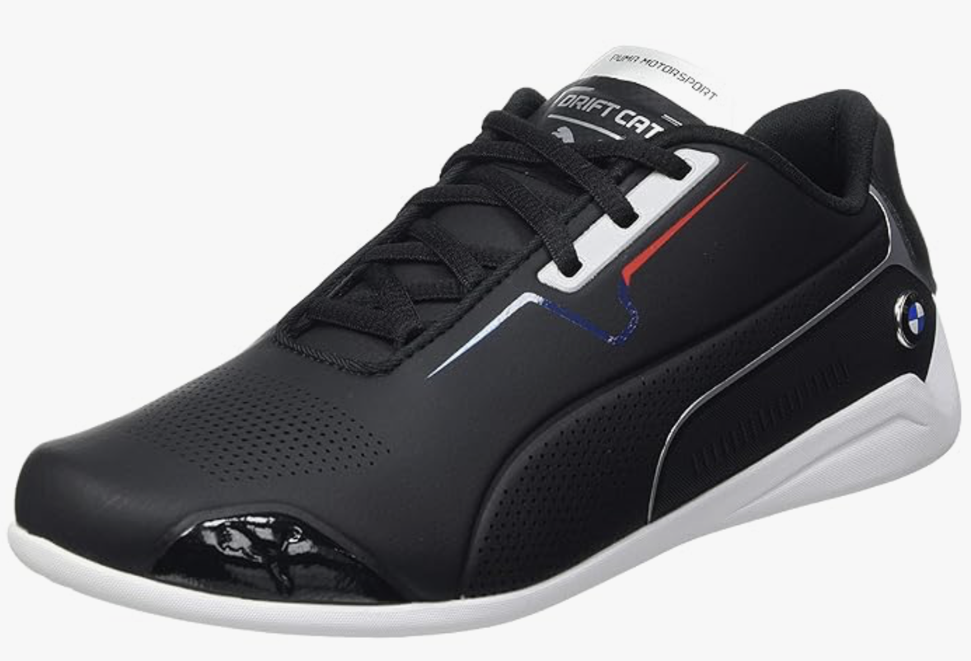

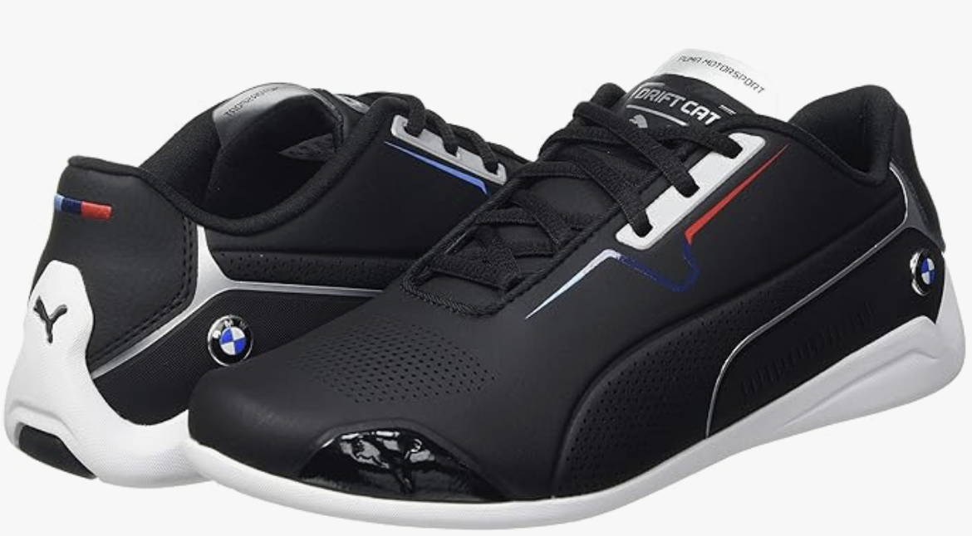

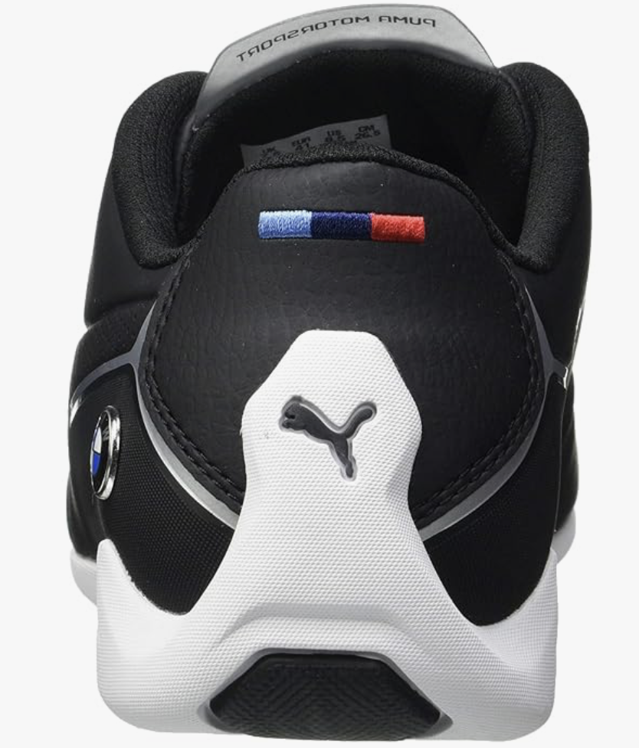

# Puma Unisex-Adult BMW MMS Drift Cat 8 Low Boot

Rubber sole, lace, Regular fit BMW M Motorsport Drift Cat 8 Shoes

Rubber, lace, bmw, shoe

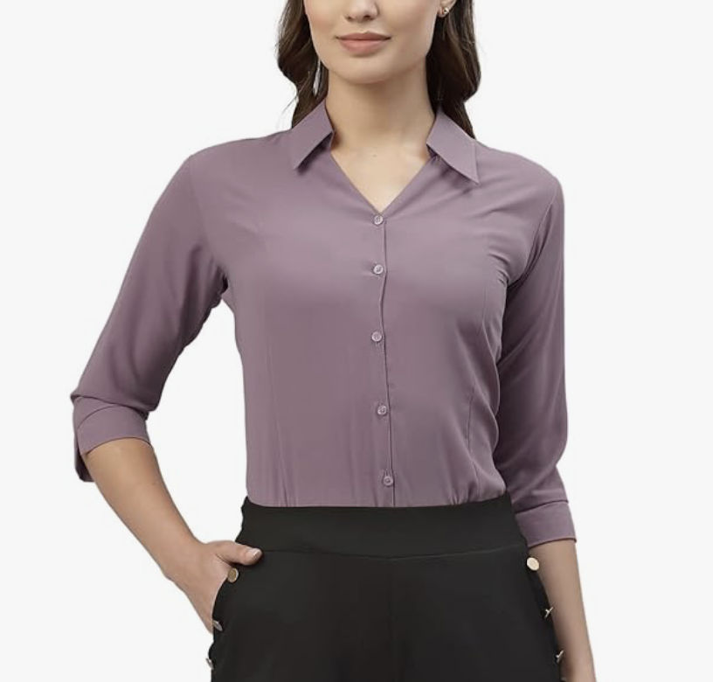

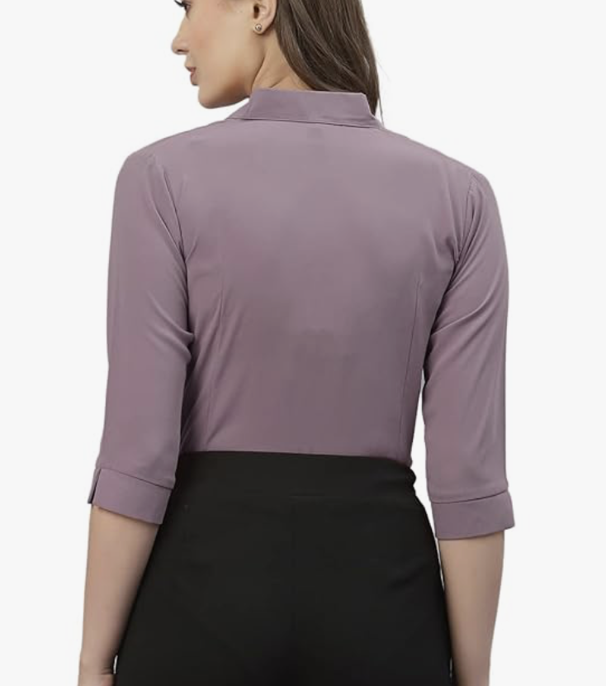

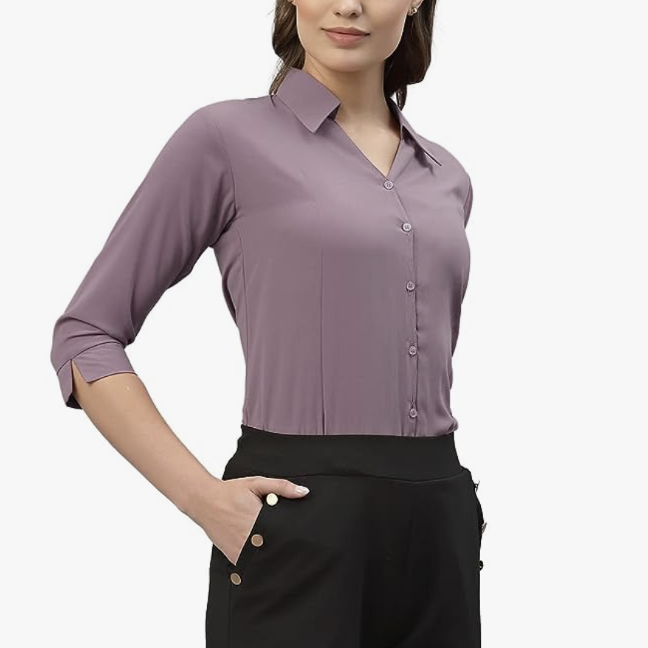

# Allen Solly Women's Poly Viscose Solid Regular Fit Shirt

# Regular Fit, Lavender formal women’s shirt

Lavender, women, shirt, regular fit

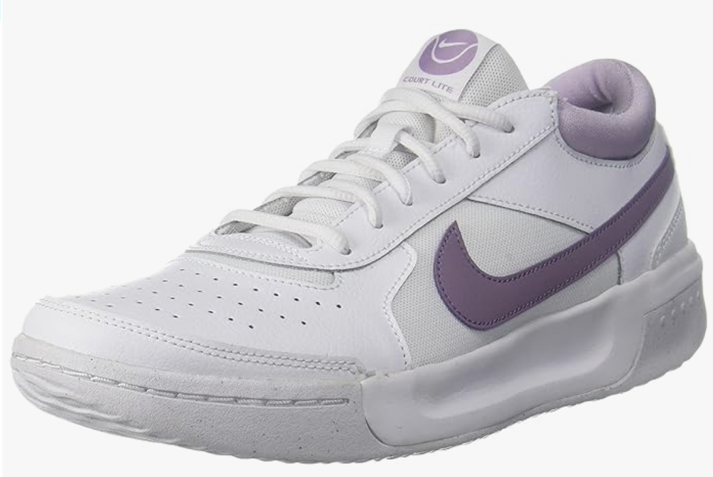

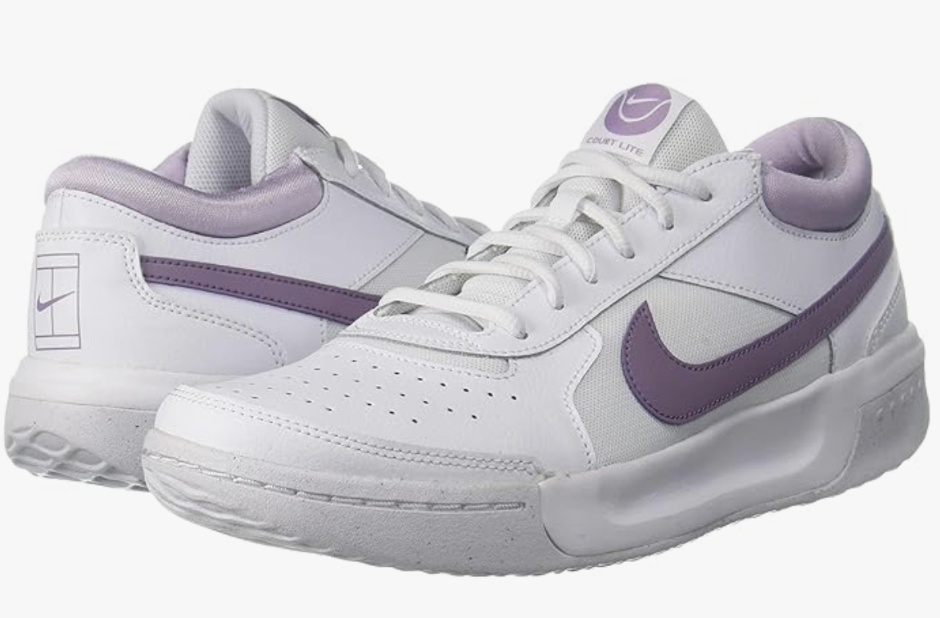

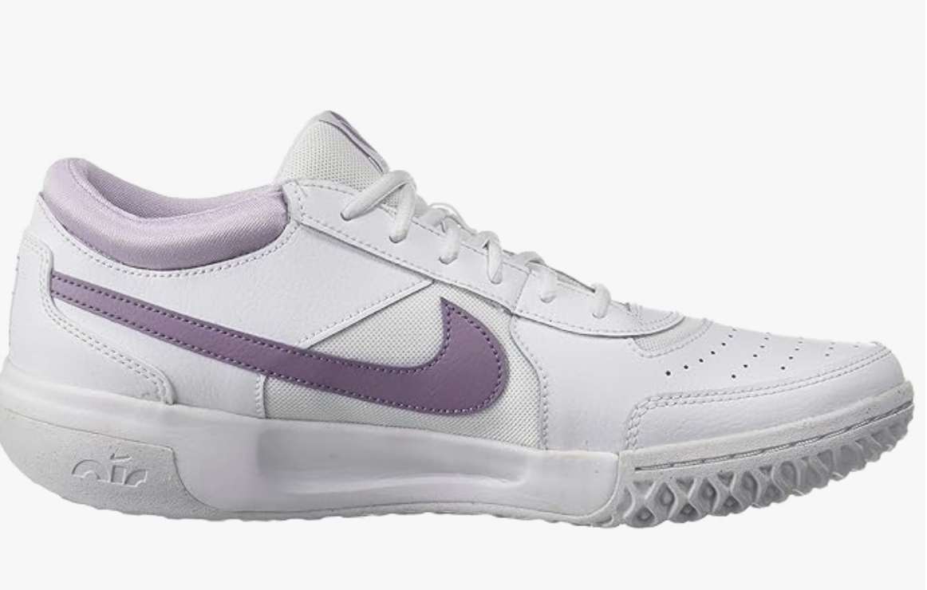

# Nike Womens W Zoom Court Lite 3 Running Shoe

White/Amethyst Nike running shoes

White, purple, lilac, amethyst, nike, shoes, women

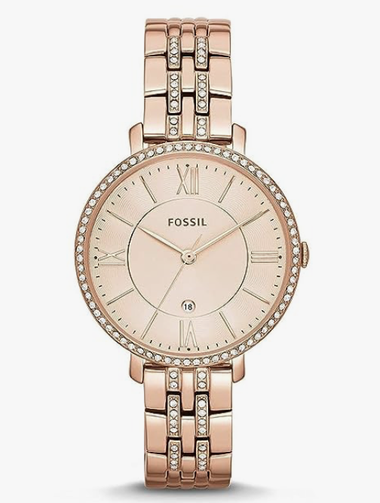

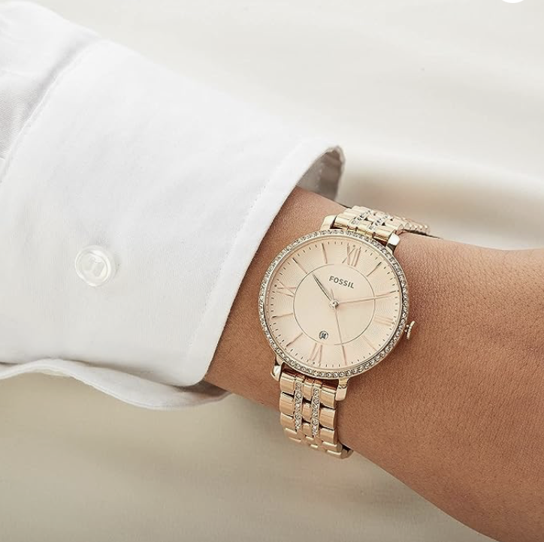

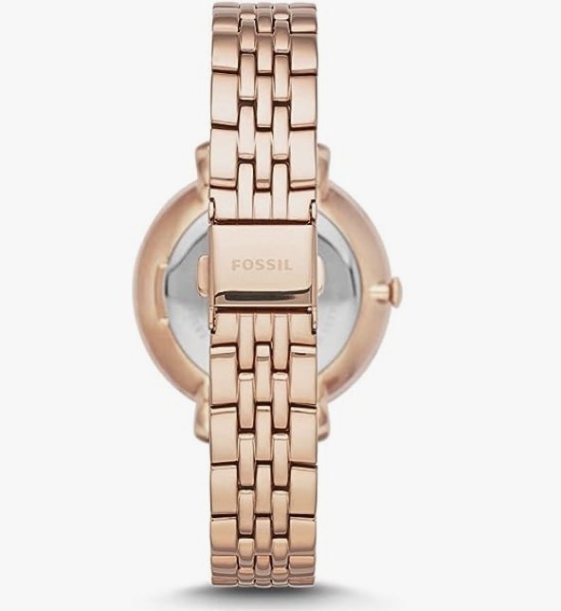

# Fossil Jacqueline Analog Rose Gold Dial Women's Watch

Rose gold, stainless steel Fossil Analog watch

Rose gold, stainless steel, Fossil, Analog, watch, women

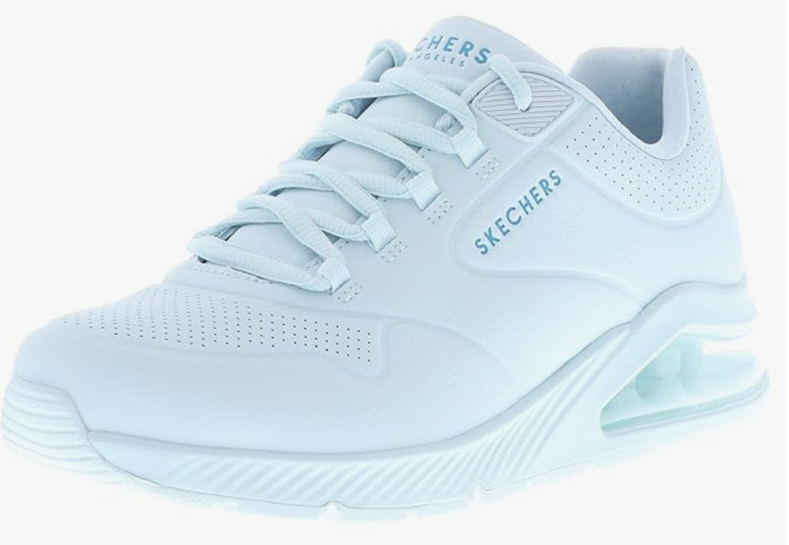

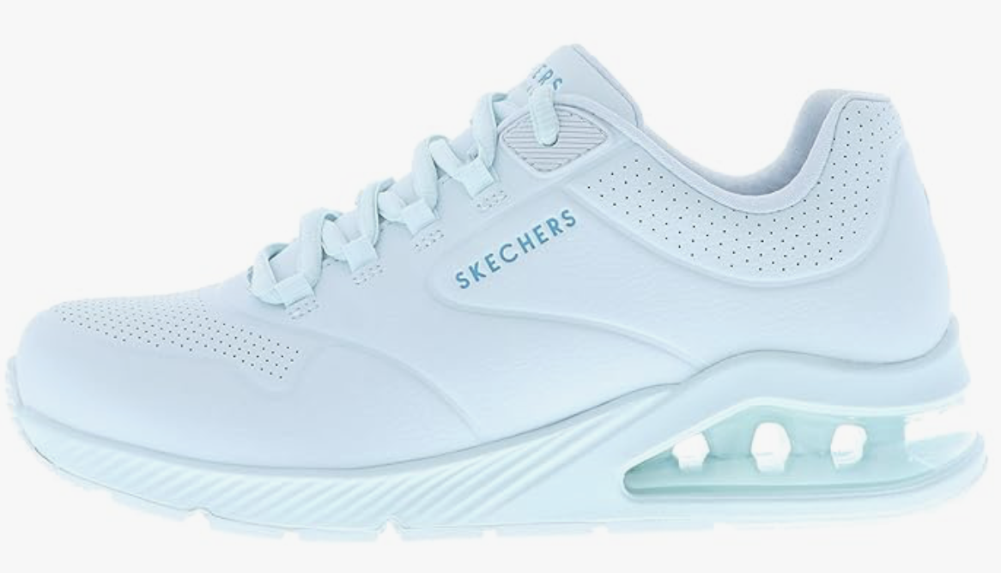

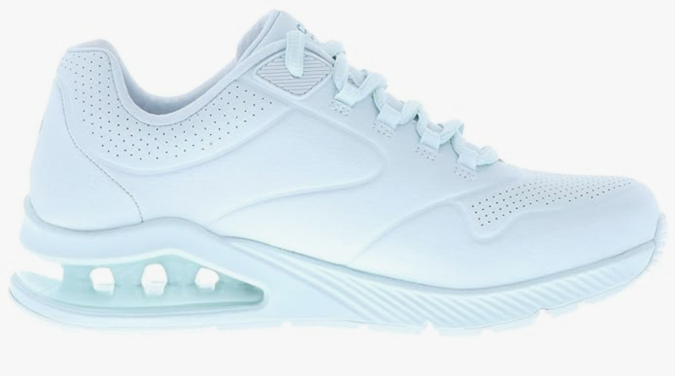

# Skechers-Womens-UNO 2 - Pastel PLAYE-Sneakers

# Pastel blue Sketchers Sneakers, regular fit, rubber sole

# Pastel blue, blue, rubber sole, regular fit, women

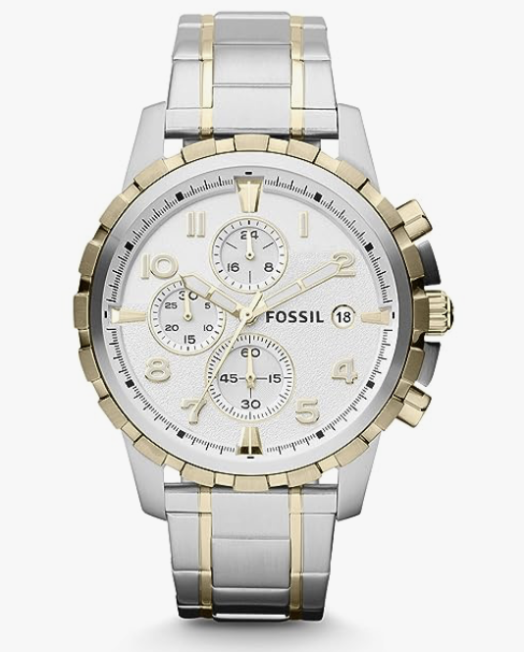

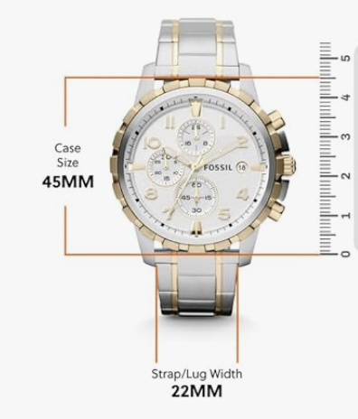

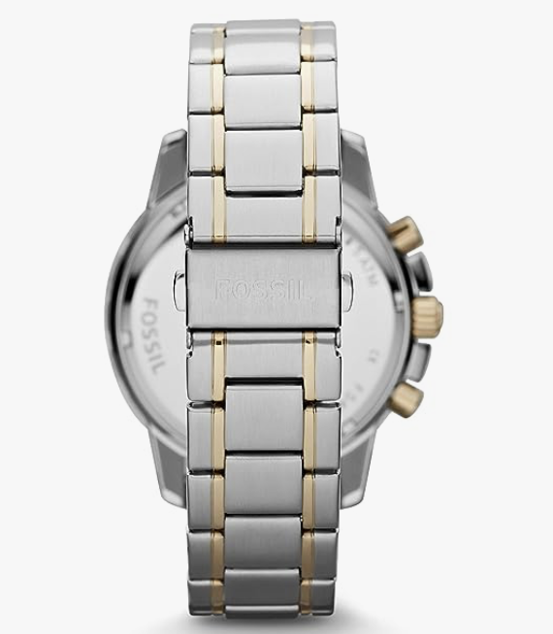

# Fossil Analog White Dial Watch-FS4795

# Silver, Stainless steel, Analog Fossil watch

# Sliver, analog, stainless steel

# 

# 

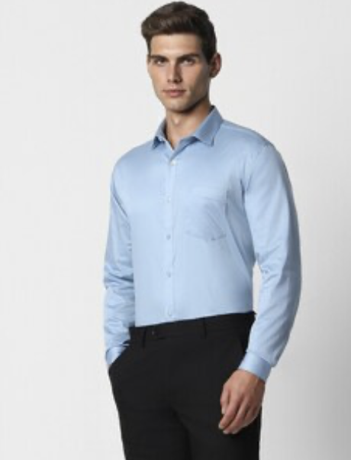

Men Blue Slim Fit Full Sleeves Formal Shirt

Sky/Light blue formal shirt

Sky blue, blue, light blue, formal, men, full sleeve

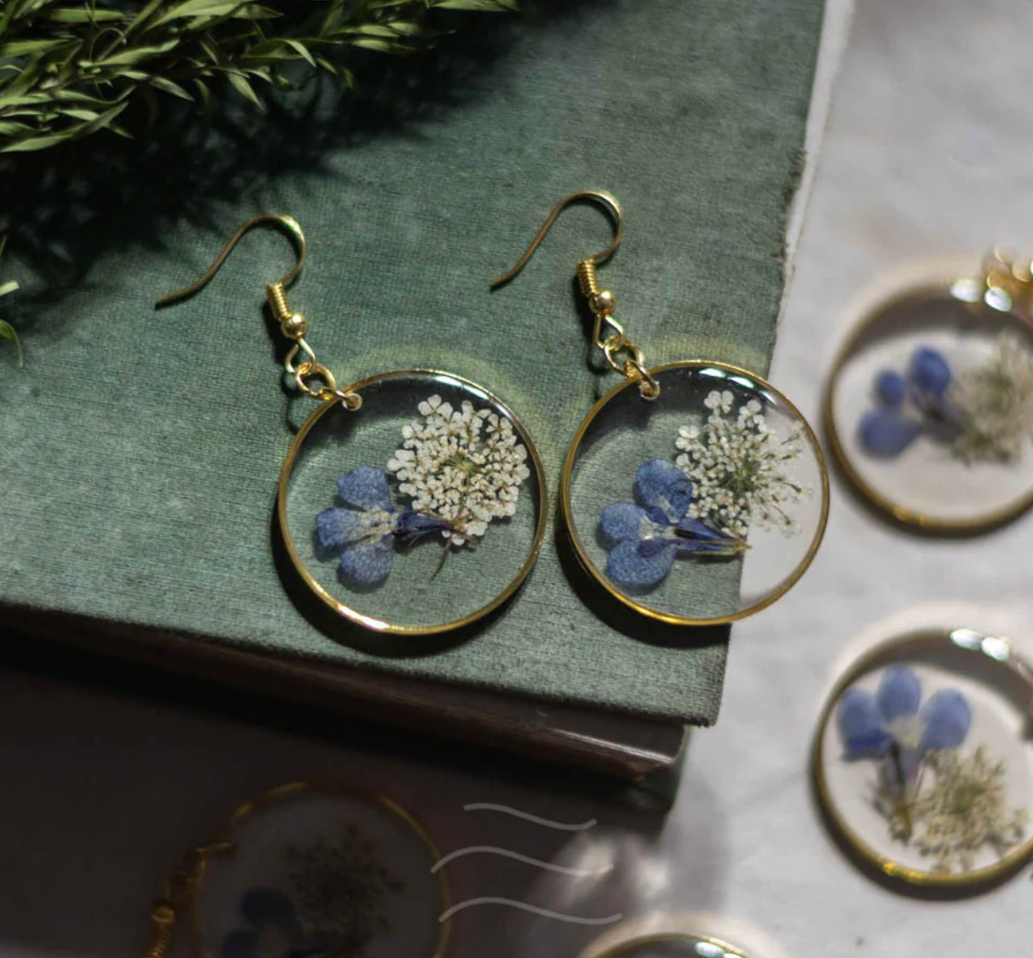

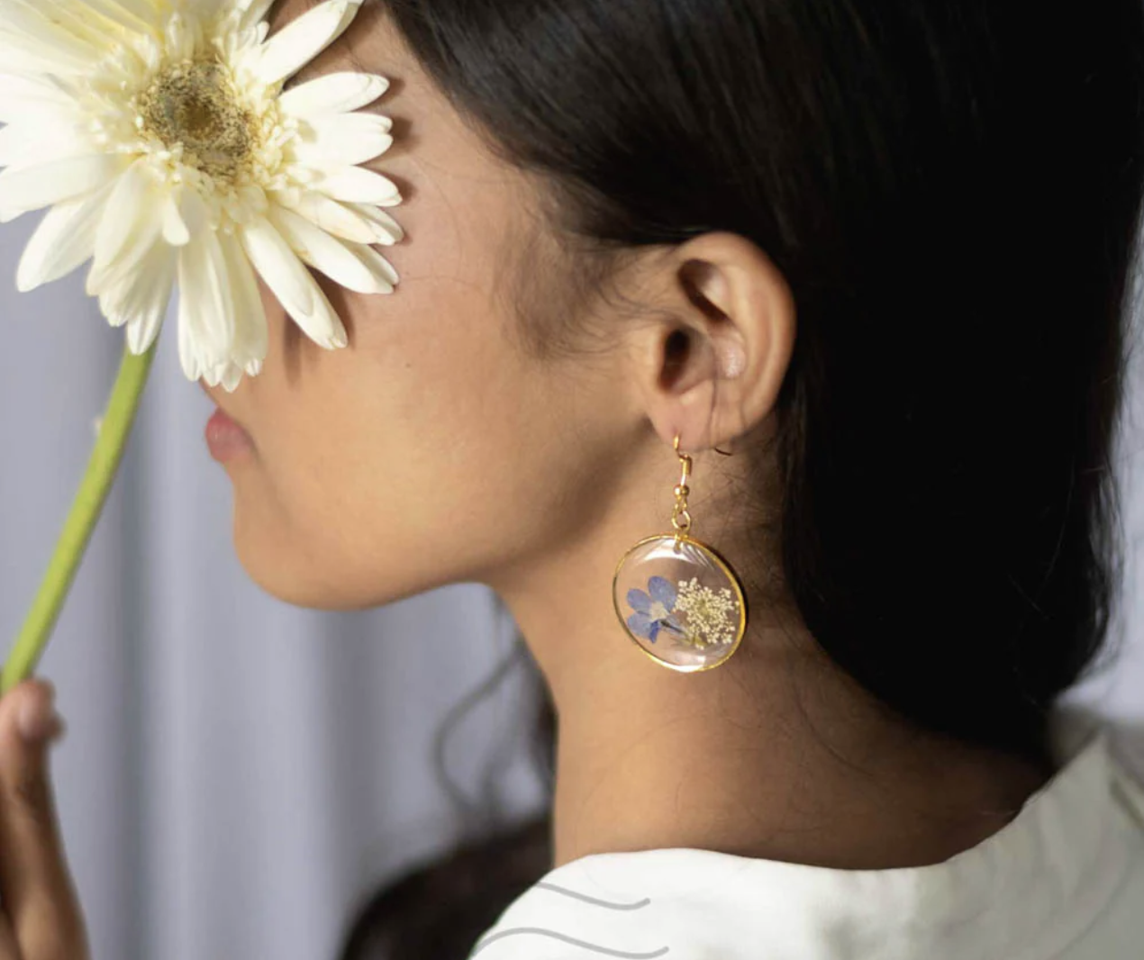

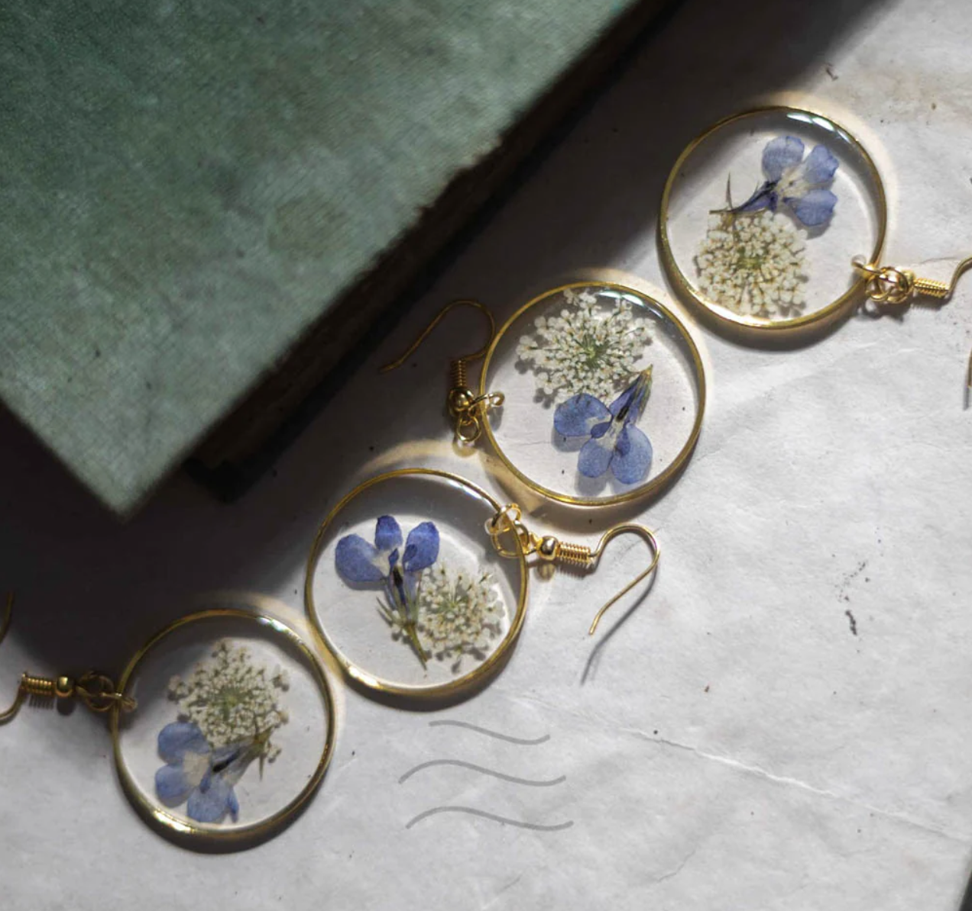

# Tinsel Flower Earrings

Pressed blue lobelia flowers and Queen Anne's lace earrings

Blue, white, flowers, earrings

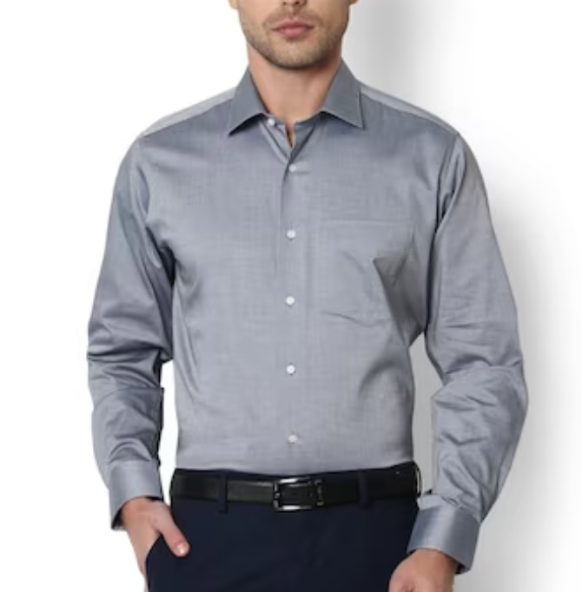

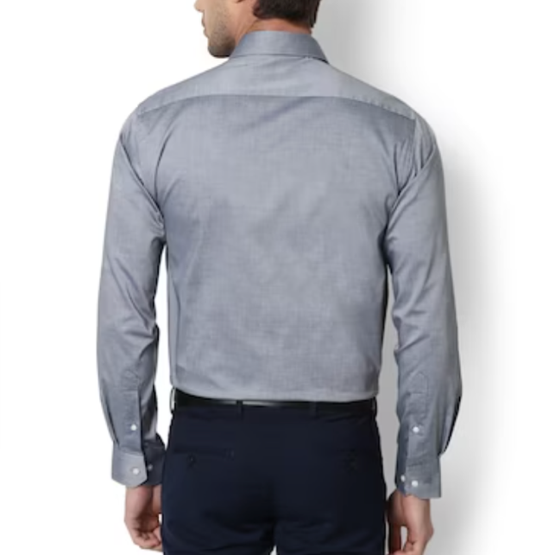

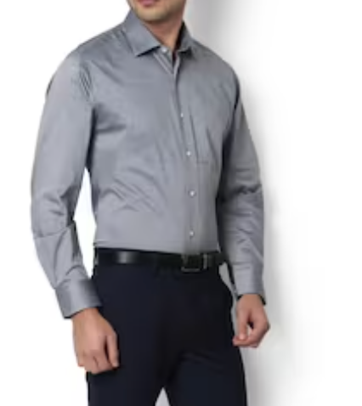

HnM Grey Formal Men’s full sleeve shirt

Grey full sleeve Formal/ Party men’s full sleeve shirt

Grey, full sleeve, men, shirt